(Sprint 3 Plan) Island Reservation

**Goal**: The goals of this sprint are to design more pages for the website and connect the frontend to the backend through multiple endpoints.

**Task listings:**

Note : User Stories carried over from Sprint 2 include Stories 1-4

**User Story 1 (Carried over from Sprint 2): As a customer of a booking service, I want a way to be able to make an account so I can save all of my bookings. (21 story points)**

Task 1: Create a Signup page (2)

Task 2: Create a Login page (2)

Task 3: Create a sign up endpoint that can send new user information to the database and a sign up schema. (4)

Task 4: Sign up new users using the sign up endpoint. (3 story points)

Task 5: Create a login endpoint that checks if the user’s information matches the information in the database and a login schema. (4)

Task 6: Log a person into their account using the login endpoint. (3)

Task 7: Implement protected routes, or pages that are only accessible after the user has signed in. (3)

Task 8: Store sessions for users to stay signed in, allowing different users to be signed in on different tabs (1)

Task 9: Implement log out functionality (0.2)

**User Story 2 (Carried over from Sprint 2): As a person who wants to reserve an island, I want a way to be able to see a list of available islands so I can reserve them. (13 story points)**

Task 1: Display the information from the island database onto the website. (3)

**User Story 3 (Carried over from Sprint 2): As a person who wants to reserve an island, I want to be able to sort the list of available islands by different criteria (like price, land size, or rating) so I can easily find the island that is best for me. (13 story points)**

Task 1: Display the island information from the various endpoints on the website (3)

**User Story 4 (Carried over from Sprint 2): As a user of an island reservation service, I want a homepage to be able to see all of my account information including the bookings that I’ve made. (13 story points)**

Task 1: Design a basic home page that has areas for the user’s account information and their bookings, which displays information about the user from the backend, and only accessible once signed in (a protected page). (6)

Task 2: Write a get endpoint that can fetch the user’s account information and be able to call it on the frontend. (3)

Task 3: Write a get endpoint that can fetch the user’s bookings and be able to call it on the frontend. (3)

Task 4: Create a protected page, accessible only from the user’s homepage, which allows the user to input credit card information and add balance to their account. (2)

**User Story 5: As a user of an island reservation service, I want a map of all of the islands so I can figure out which ones are closest to me. (13 story points)**

Task 1: Figure out how to implement the Google Maps API. (5)

Task 2: Add a Google Maps map to the website. (4)

Task 3: Display and mark all island locations where the user can travel to. (2)

Task 4: Display the user’s location. (2)

Task 5: Write a get endpoint that takes in user coordinates and returns a sorted list of nearby islands (1)

Task 5: Use the endpoint to display a list of nearby islands sorted by ascending distance from the user. (3)

**User Story 6: As a user, I want to be able to see an About page describing the product I am using so that I understand all the features of the product. (5 story points)**

Task 1: Design a page which contains a description of the product and website features (5)

Task 2: Add a section to the page that has blurbs about each person on the team (2)

Task 2: Add a link to the navigation bar which takes the user to the About page. (0.5)

**Team roles:**

Abdel Rahman Alnajjar : Frontend Developer

Suneet Bhandari : Frontend Developer

Minghui Wen : Frontend Developer

Maiah Pardo: Frontend Developer

Jonathan Ly : Backend Developer

Wilson Chen : Backend Developer

Jose Jimenez : Backend Developer

**Initial Task Assignment:**

Minghui Wen: User Story 2, Task 1 about page.

Abdel Rahman alnajjar: User Story 1, Task 1 ???.

Wilson Chen: User Story 1, Task 4 signup login.

Suneet Bhandari: User Story 2, Task 1 google maps page.

Jonathan Ly: User Story 2, Task 2 sign up endpoint.

Jose Jimenez: User Story 3, Task 1 storing picture urls in the db.

Maiah Pardo: User Story 1, Task 1, Finish the sign up page, User Story 1, Task 2, Finish the log in page, User story 4, Task 1 working on logged in home page.

**Burnup Chart:**

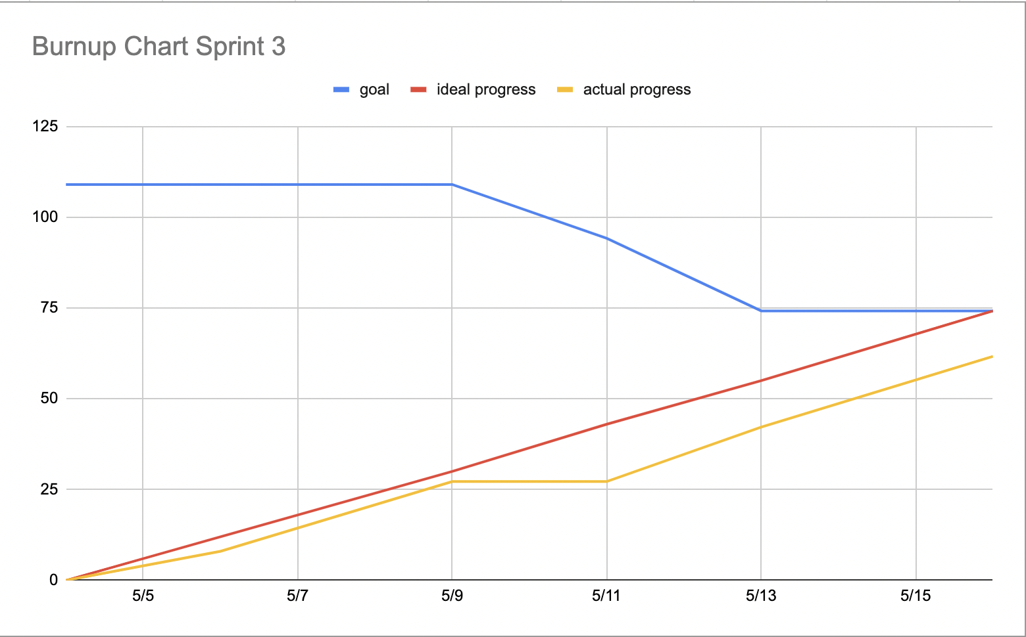

**Scrum Board:**

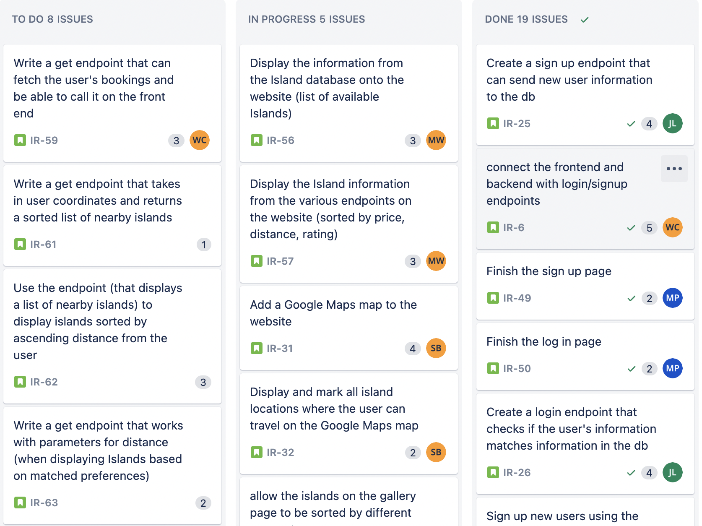

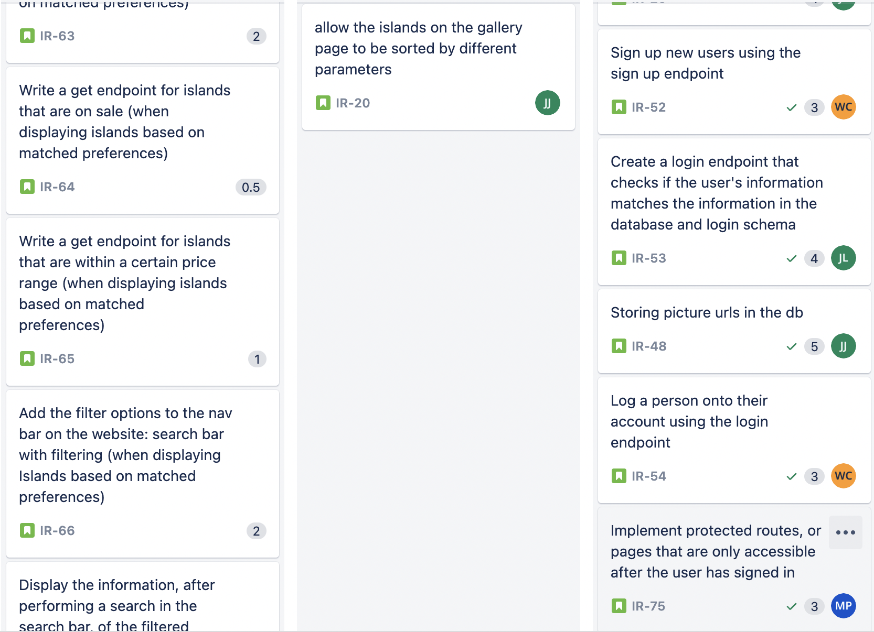

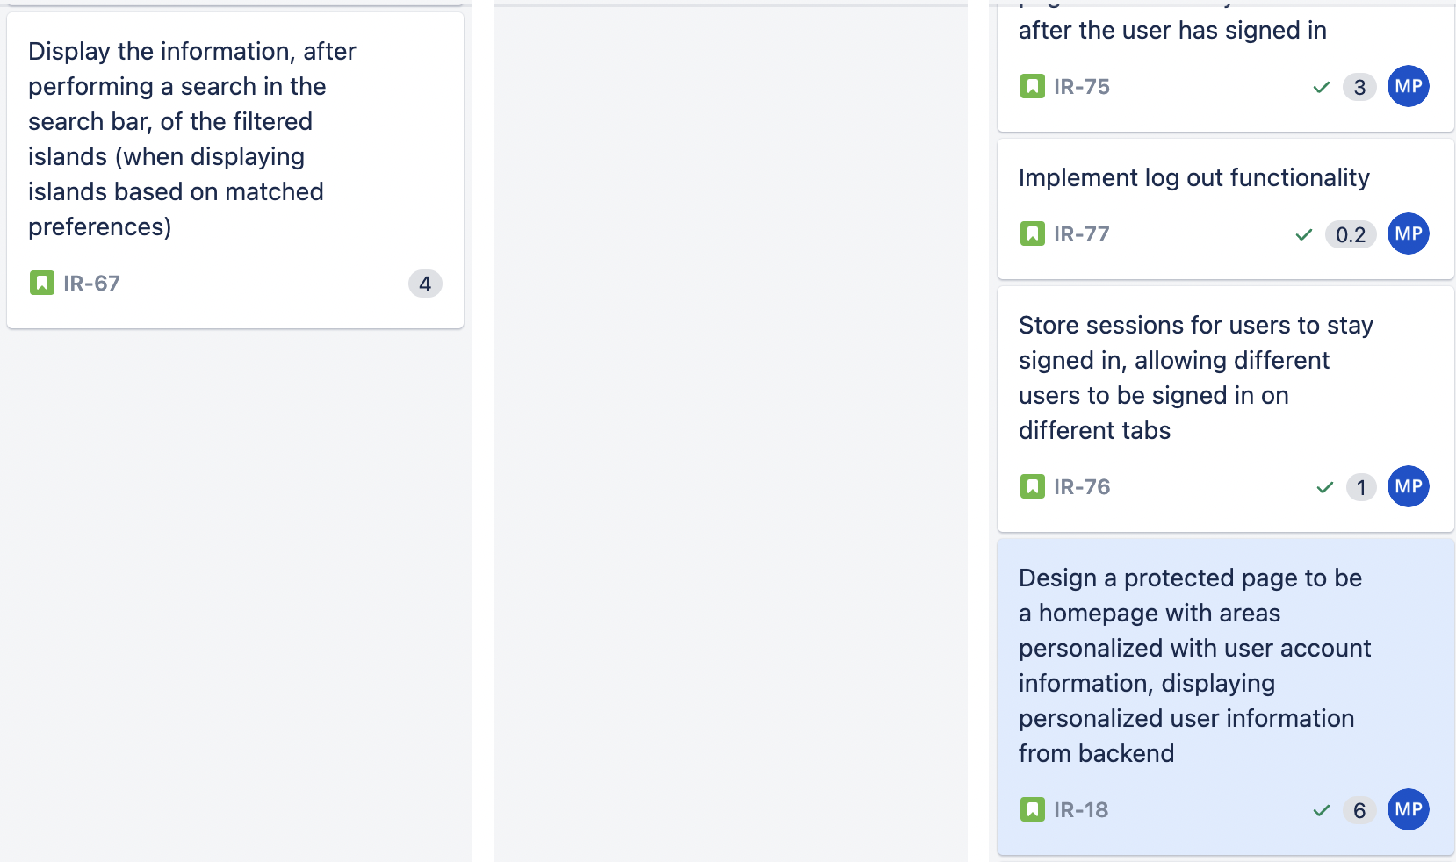

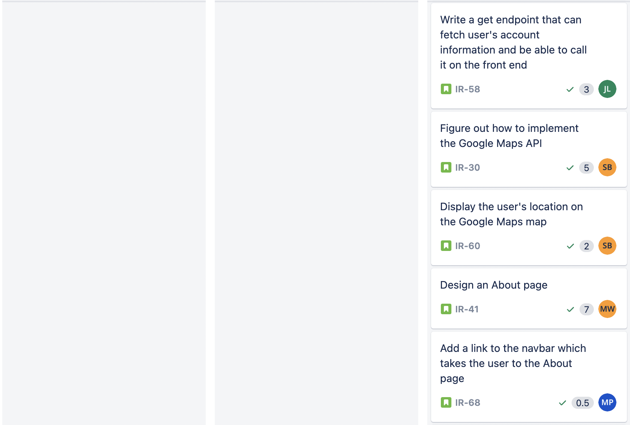

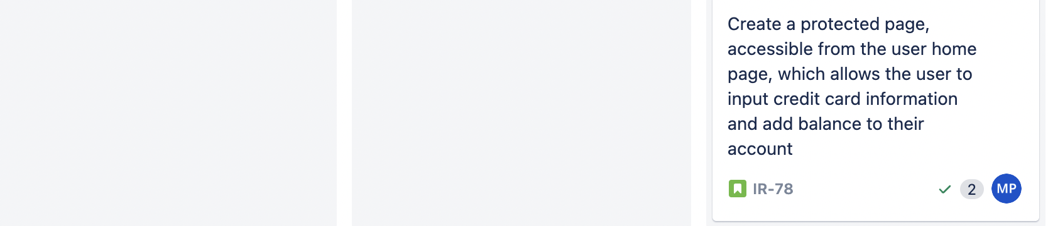

<https://islandreservation.atlassian.net/jira/software/projects/IR/boards/1>

**Scrum Times:**

Mon/Wed/Fri : 9:05 - 9:30 am

TA meeting: Monday Trevor 1:30 - 2:45 pm